Annex A3.6 Value For Money

Our series have been aired by far more broadcasters, more often, than originally anticipated. Although each of the series has had a national broadcaster, Kenya and Cote d’Ivoire broadcast all across sub-Saharan Africa on CFI. Kenya, Zimbabwe currently are broadcast in the UK on the Community Channel. The Cote d’Ivoire series will soon be seen on that channel as well. The Kenya series airs on Link TV in the United States. 4 series (Kenya, Indonesia, Cote d’Ivoire, Zimbabwe) have been nominated for television awards in their respective countries. The Cote d’Ivoire series was chosen for the 2009 Fespaco Festival in Burkina Faso, the most prestigious African film and television festival on the continent. Each of the series has been or will be in re-runs. Our Angola series is likely to be broadcast again on national TV and we are looking at airing it in neighboring Mozambique. Through streaming video and audio we can make both radio and TV series available on websites. Additionally, we have raised co-funding for the project that has at least doubled the value of the original grant. We have received additional funds from USAID, EIDHR, the EU/NSA, AED, the MacArthur Foundation, the US State Department and FCO in multiple countries. We have been underwritten by the private sector including SNRT in Morocco, Unilever in Kenya, RTI in Cote d’Ivoire. While most of our competitors pay for air time, we do not, thus this results in a substantial savings.

The popularity of the series has sparked support from donors and we have started projects in Pakistan, Yemen and Tanzania. Interest in starting additional projects are in Myanmar, Sri Lanka, Libya and Tunisia.

The mobile cinema and dialogue projects have been robust with more of a reach than we originally anticipated.

Annex A4 – Material produced during the reporting period:

Item | Date | Title of Material | Description | Web link
1. Angola TV | Jan-March 2011 | O Equipa | 15 episodes
2. Burundi: radio | June-Sept 2011 | Intamenwa! | 32 radio eps
2.a Burundi: spots | same |  | 4 peace messages
2.b Burundi | same |  | 2 TV spots
2. c Burundi | same |  | Music competition
3. Cote d’Ivoire | Dec 2011 | Mobile cinema | Screenings/dialogue
4. CIV | March 2012 | L’Equipe | Short film
5. CIV | March 2012 | Evaluation
6. DR Congo | March 2012 | Evaluation
7. DR Congo | Nov-Dec 2011 | L’Equipe | 11 episodes TV
8. Indonesia | Feb 2012 | Tim Bui
9. Nepal | June 2011 | Hamro Team | 13 episodes TV
10. Kenya | July – Sept 2011 | The Team | 13 episodes TV
11. Kenya | July –Oct 2011 | mobile screenngs/dialouge | 48 screenings
12. Kenya | Nov-Dec 2011 | The Team | 52 episodes vernacular radio (4 languages, 13 episodes each)
13. Kenya | March 2012 | Final Evaluation
14. Liberia | April 2011-March 2012 | The Team screenings | 40 screenings and dialogues
15. Sierra Leone | Aug 14-Dec 18 2011 | The Team | 10 episodes TV
16. Nepal | March 2012 | Hamro | Short film - outreach
17. Zimbabwe | Jan-Feb 2012 | The Team | Screenings: 6 locations across Zimbabwe

Annex A5.1 Web update

In its multi-nation, episodic drama The Team, Search for Common Ground has merged the global appeal of soccer/football* with soap opera to help transform social attitudes and diminish violent behavior in countries grappling with deeply rooted conflict. The television series addresses the very real divisive issues facing societies in a dozen African, Asian and Middle Eastern countries, using sport as a unifier to surmount barriers. Each production of The Team follows the characters on a football team who must overcome their differences – be they cultural, ethnic, religious, tribal, racial or socio-economic – in order to work together to win the game.
The Team rings true for viewers, given that all of the series are created and produced locally. Actors and scriptwriters, who have experienced violent conflict and divisions firsthand, are drawn from local populations in the countries in which we work. Local production companies and technicians take the lead, with additional technical assistance and support from Common Ground Productions. Inspired by worldwide passion for football, The Team sparks in viewers a sense of belonging to a whole that transcends often narrowly-defined identities. In this reporting year, the series was broadcast for the first time in Angola, Burundi (radio) Indonesia, Nepal, Sierra Leone and Zimbabwe with ongoing projects in Cote d’Ivoire, DR Congo and Kenya.

Articles about The Team from around the world:

http://www.sfcg.org/programmes/cgp/the-team-articles.html

Annex A5.2: Photographs

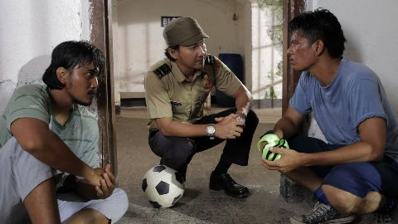

Tim Bui: The Team, Indonesia : Agus Koncoro, seen in the middle, won the Best Actor award in May 2012 at the Bandung Film Festival for his portrayal of Agung, the prison guard who is the peacemaker. The series was nominated in 8 categories including Best Drama.

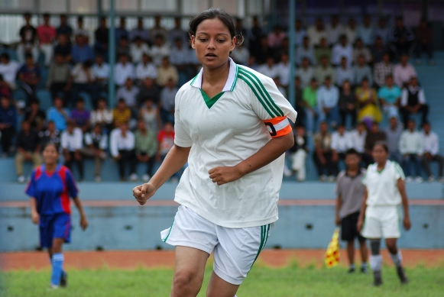

“Seema”, the controversial lead character of The Hamro Team,
Nepal as played by Richa Sharma.

Annex A5.3

The Team Funding page on the SFCG website

http://www.sfcg.org/programmes/cgp/the-team-funding-report.html

